Angel Lane Surgery

AUTUMN/WINTER 2017 NEWSLETTER
Produced by the Patient Participation Group on behalf of the Surgery
Members of PPG:- Dr Linn, Practice Manager Alison Couldry, Patients: June Milne – Secretary, Philip Milne – Treasurer, Wendy Barron, Margaret Cole, Margaret & Barrie Easter, Susan Leslie, Terry Moore.

FLU CLINICS
This years Flu Clinics started in September. There will be one on 14th October and one on 4th November. Please book an appointment if you have not already done so. Thank you to Dunmow Women’s Institute for providing the refreshments. again
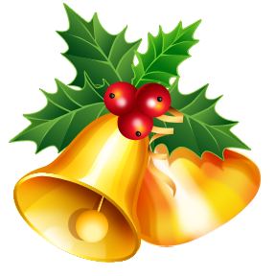

Please support The Raffle being run by PPG members at the Flu Clinic. The proceeds will go towards updating the patient toilet
****************
FUND RAISING
We say a BIG THANK YOU to Practice Manager Alison who again took part in the Tour of Cambridge Cycle Ride on 4th June and raised £303.08 for the Surgery.
SURGERY NEWS
There have been a number of improvements to the building including an extra consulting room, a new electronic door and a new patient call system.

The Surgery Team consists of:-
CHRISTMAS SURGERY TIMES
22nd December Normal times
23rd “ CLOSED
24th “ CLOSED.
25th “ CLOSED
26th “ CLOSED
27th – 29th “ Normal times
1st Jan 2018 CLOSED
2nd “ Normal times
On closure dates the NHS 111 service is available 24 hours a day.
.
Doctors and GP Trainees,
Nurses and Dispensary Staff and
Reception/Admin Staff.

A very big thank you to the whole team
who make our Practice such a
welcoming, well run establishment.

Despite the increased work load,
the average waiting time for an
appointment is one week

Remember the Evening & Weekend Surgery at Dunmow Clinic which is working very well and can be booked in the normal way via the Surgery
NHS FREE Health Check. Aged 40 – 74?
Even though you might be feeling great, if you are over 40 you may be at risk of heart disease, stroke, kidney disease, diabetes or dementia.
A FREE NHS Health Check can help you reduce these risks and make sure you stay healthy. Contact the Surgery to make an appointment.
WISHING YOU A VERY MERRY CHRISTMAS AND
A HAPPY AND HEALTHY NEW YEAR

